Head and Neck Questionnaire

I. Name: _________________________ Age: ______________

Date: ________________ Referred By: ________________________

II. Which of the following do you have: (circle all that apply)
Headaches Neck pain Jaw pain Ear pain

Facial pain Other: _____________________________________

Which side hurts: (circle one) Right Left Both

Comments_____________________________________________________

III. Place an (X) in the circle(s) where you hurt.
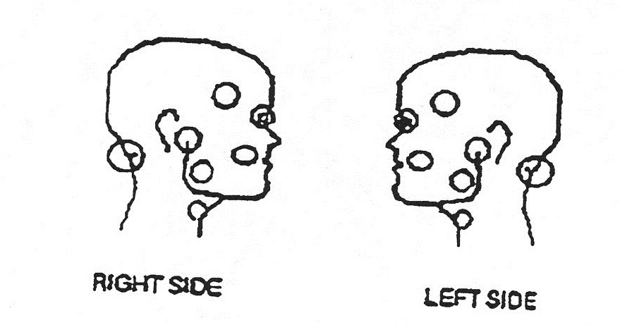

IV. How long have you had this pain? __________________________
Is the pain constant?______________________________________
Is the pain: (circle all that apply)
Aching Burning Stabbing Other: __________

V. Is the pain the worst in the: (circle all that apply)
Morning Afternoon Evening Night

VI. Have you ever injured or sustained any form of trauma or whiplash to your:
(circle all that apply)
Jaw Head Neck

VII: What makes the pain better?__________________________________________________________________

What makes the pain worse?__________________________________________________________________

What medications do you take or have you previously taken for your pain?
Medication Dose Frequency
___________________ _______________ _____________________

___________________ _______________ _____________________

___________________ _______________ _____________________

VIII: Have you had any prior treatment for TMJ? Y N
Splint? Y N When?__________ Did it help? Y N
Nightguard? Y N When?__________ Did it help? Y N
Bite adjustment? Y N When?__________ Did it help? Y N
Orthodontics? Y N When?__________ Did it help? Y N
Other?_________________________________________________________________________________________________________________________________________

IX: Describe the problems in your own words as you understand them. ________________________________________________________________________________________________________________________________________________________________________________________________________________________________________________________________________________________________________________________________________________________________________________________________________________________________________________________________________________________________________________________________________________________________________________________________

X: I have completed the above to the best of my knowledge and I personally have filled in each blank in my own writing. I consent to the use of my X-rays, records and photos for scientific publication or teaching providing my name remains anonymous.

Signature: __________________________________________________

Date: ___________________________________________________

